**SPRINT 2**

|  |  |
| --- | --- |
| Team ID | PNT2022TMID50177 |
| Project Name | Smart Waste Management System for Metropolitan Cities |

**AIM:**

To create device in the IOT Watson Platform and Configure Node Red Services.

**REQUIREMENT:**

IBM cloud, IBM IOT WATSON PLATFORM, NODE RED SERVICES.

**WORKFLOW:**

**STEP1:**

Log on to IBM cloud and create IBM Watson IOT Platform from IBM cloud Dashboard.

**STEP2:**

After Creating IBM Watson IOT Platform, create an Organization.

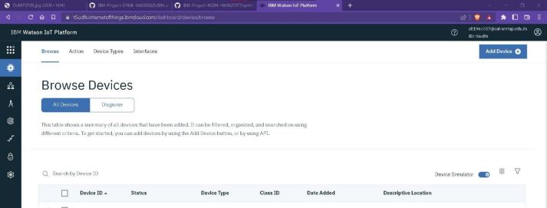

**STEP3:**

Create an device IBM IOT PLATFORM.

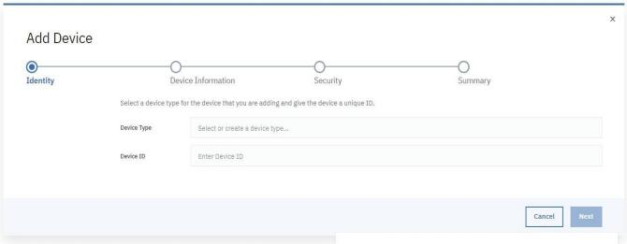

TYPE THE REQUIRED FIELDS(TYPE:Raspberrypi,ID:

12345)GIVEAUTH-TOKEN.

**STEP4:**

NODERED SERVICE

INSTALL IBM IOT IN MANAGE PALETTE.

INSTALL NODE RED DASHBOARD.

**STEP5:**

**Configuring the corresponding nodes**

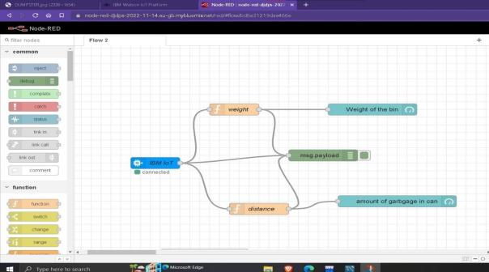

**STEP6:**

Deploy the Services and verify the output values.

**OUTPUT IN IBM WATSON IOT PLATFORM:**

